FootFusion

Use-case-Realization Specification: Manage Information

Version 1.0

Revision History
Date | Version | Description | Author
26/11/2024 | 1.0 | Final Version | Vu Thi Anh Thu

Table of Contents
1. Introduction 2
1.1 Purpose 2
1.2 Scope 2
1.3 Definitions, Acronyms, and Abbreviations 2
1.4 References 2
1.5 Overview 2
2. Flow of Events—Design 2
3. Derived Requirements 2

Use-case-Realization Specification: Manage Information

Introduction

Purpose
The purpose of this specification is to define how the Manage Information use case is realized during the design phase. It outlines the interactions between admin and the system, identifies key system components (e.g., user interface, database, and APIs), and models the objects and sequences necessary to implement the functionality.

Scope
The scope of this Use-Case Realization Specification is to define the analysis and realization of the Manage Information use case within the system. This specification is directly associated with the Manage Information use case model, which enables admin to edit, and save homepage content.

Definitions, Acronyms, and Abbreviations
None.

References
None.

Overview
The following sections of the document detail the design and derived requirements for the implementation of the use case. The Flow of Events - Design section focuses on the design aspects of the use case, providing a textual explanation that outlines the steps and interactions involved. It also includes a sequence diagram that visually represents the chronological order of interactions between the actors and system components. Additionally, a class diagram is presented, illustrating the relevant classes and their relationships within the context of the use case. Together, these elements offer a thorough understanding of the design choices and system behavior associated with the use case.
Furthermore, the document outlines the derived requirements that must be considered during the implementation phase. These requirements define the functionalities, constraints, and system behaviors necessary to fulfill the use case's objectives. They serve as essential guidelines for developers and stakeholders to ensure that the system meets the expected standards and operates as intended.

Flow of Events—Design
The admin clicks on the "Home" section, which loads the homepage content into the HomepageUI. The admin can then click the "Edit" button to update the homepage content.
The PageController handles the content updates, retrieving the current content from the HomepageUI, allowing the admin to modify it, and then saving the changes to the HomepageEntity.
Finally, the system saves the updated homepage content.

sequence diagram
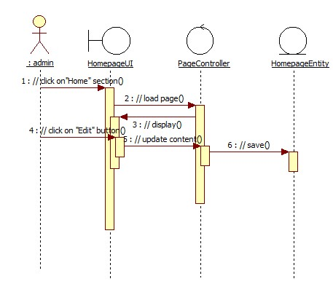

class diagram
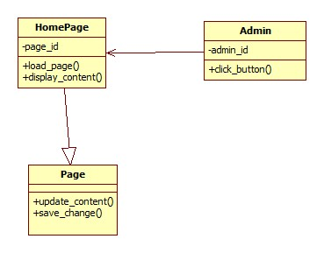

Derived Requirements
- The system must process and update information within 5 seconds of submission to ensure a fast and responsive user experience.

